

The 13th PREŠOV OPEN 2015
INTERNATIONAL TOURNAMENT
TAEKWON-DO ITF



14. – 15. March 2015

ZŠ Sibírska, Prešov

www.gebaek.sk

General informations:

1. The head of organizing committee:
Tomáš Olejár, e-mail: gebaek.presov@gmail.com

ENTRY FORMS
- The forms/competitor entry forms and accomodation forms/ please send to :

FAX: +421 51 77 44 773
E-mail: gebaek.presov@gmail.com
(We accept only entry forms fill in PC)

2. Registration:

REGISTRATION DEADLINE:

Pre-registration - 4th march 2015 (until midnight)
Modifications - 11th march 2015 (until midnight)

ATTENTION!!! Pre-registration must be completed by all clubs until the first deadline. We can only accept an modifications (injuries, illnes, ...)from these clubs only.

3. Date and place:
March 14th to 15th 2015, Prešov- Slovakia

4. Address:
Sport Hall ZŠ Sibírska, Prešov
Sibírska 42
Prešov
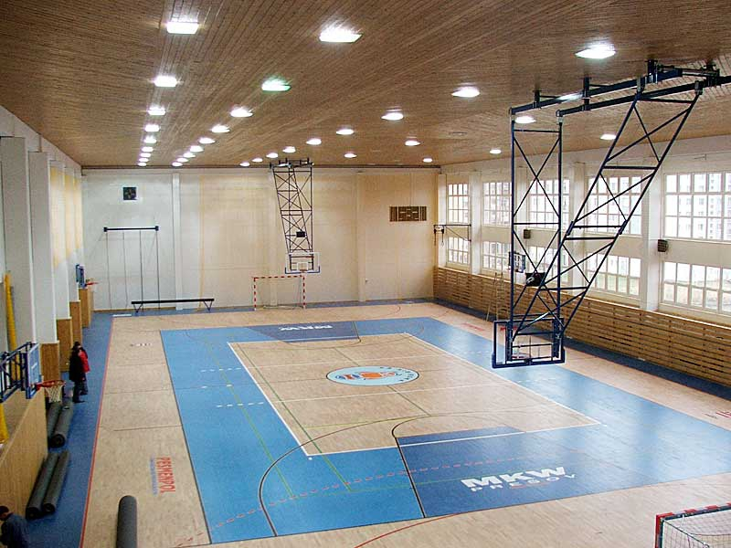

5. Division/ Categories:

• Divisions/categories must consist of two or more competitors – if there is only one competitor he/
she will compete in a lower or higher category or division,
• Black belts m/f, coloured belts m/f,
• Children 6 – 10 years old, children 10 – 14 years old, juniors (15-17), seniors (18+),
• The event takes place in a round-robin system supported by a seeded draw, in case that in one
cathegory is more than 5 competitors, cathegory will be divided into groups and winners of the group
will continue in semifinals,
• The competitors have to have doctor control not older then 1 year.

INDIVIDUAL EVENTS

PATTERN DIVISIONS CHILDREN 6-10 YEARS OLD M/F:

• the competition is for competitors who have 10.kup and higher,
• pattern finals – one designated and one optional pattern,
• categories: : 10-8 kup, 7-6 kup, 5-4 kup, 3-1 kup, 1 dan, 2 dan and so on.

PATTERN DIVISIONS CHILDREN 10 – 14 YEARS OLD M/F:

• the competition is for competitors who have 10.kup and higher,
• pattern finals – one designated and one optional pattern,
• categories: : 10-8 kup, 7-6 kup, 5-4 kup, 3-1 kup, 1 dan, 2 dan and so on.

PATTERN DIVISIONS JUNIORS/SENIORS M/F:

• the competition is for competitors who have 10.kup and higher,
• pattern finals – one designated and one optional pattern,
• categories: 10-8 kup, 7-6 kup, 5-4 kup, 3-1 kup, 1 dan, 2 dan and so on.

SPARRING DIVISIONS CHILDREN 6 – 10 YEARS OLD M/F:

• children – male: -23kg, -27kg, -31kg, -35kg, -40kg, -45kg, +45kg
• children – female: -23kg, -27kg, -31kg, -35kg, -40kg, -45kg, +45kg
• one round 1x1,5minutes STOP SYSTEM
• finals 1x1,5 minutes STOP SYSTEM
• all children have to wear head guard protectors during the sparring.

SPARRING DIVISIONS CHILDREN 10 - 14 YEARS OLD WEIGHT CATEGORIES M/F:

• children – male: -30kg, -35kg, -40kg, -45kg, -50kg, -55kg, +55kg
• children – female: -30kg, -35kg, -40kg, -45kg, -50kg, -55kg, +55kg,
• two rounds 2x1,5minutes STOP SYSTEM
• finals 2 x1,5 minutes STOP SYSTEM
• all children have to wear head guard protectors during the sparring.

SPARRING DIVISIONS JUNIORS /SENIORS– WEIGHT CATEGORIES M/F:

• juniors male: -50kg, -56kg, -62kg, -68kg, -75kg, over 75kg,
• juniors female: -45kg, -50kg, -55kg, -60 kg, -60kg, -65kg, over 65kg,
• seniors male: -57kg, -63kg, -70kg, -78kg, -85kg, over 85kg,
• seniors female: -50kg, -56kg, -62kg, -68kg, -75kg, over 75kg,
• two rounds 2x2 minutes STOP SYSTEM
• finals 2x2 minutes STOP SYSTEM
• all juniors and seniors have to wear head guard protectors during the sparring.

SPECIAL TECHNICS CHILDREN 6-10 M/F:
- from 10. kup and higher,

Technics | Children male | Children female
Twimyo nopi apchagi | 130 cm | 130 cm
Twimyo jopcha jirugi | 60 cm | 60 cm

SPECIAL TECHNICS CHILDREN 10-14 M/F:
- from 10. kup and higher,

Technics | Children male | Children female
Twimyo nopi apchagi | 160 cm | 160 cm
Twimyo jopcha jirugi | 80 cm | 80 cm

SPECIAL TECHNICS DIVISIONS JUNIORS/SENIORS M/F:
- from 10. kup and higher,

Technics | Juniors male | Juniors female | Seniors male | Seniors female
Twimyo nopi apchagi | 230 cm | 190 cm | 260 cm | 220 cm
Twimyo dollyo chagi | 210 cm | 180 cm | 240 cm | 200 cm
Twimyo jopcha jirugi | 120 cm | 110 cm | 140 cm | 120 cm
Twimyo bandae dollyo chagi | 210 cm | - | 220 cm | -
Twimyo dolmyo yopcha jirugi | 210 cm | - | 220 cm | -

POWER BREAKING DIVISIONS JUNIORS/SENIORS M/F:
- from 4. kup and higher,

Technics | Sonkal yop taerigi | Yopcha jirugi | Dollyo chagi | Ap yoomuk jirugi | Bandae dollyo chagi
Junior M | 2 boards | 3 boards | 2 boards | 1 board | 1 board
Junior F | 1 | 2 | 1 | - - - | - - -
Senior M | 2 | 3 | 2 | 2 | 2
Senior F | 1 | 2 | 2 | - - - | - - -

TEAM events

DIVISIONS OF THE CHILDREN 6 – 14 YEARS OLD TEAM PATTERN M/F:

• team must consists of 5 persons,
• the possibility to combine several practitioners of clubs into one team,
• the possibility to combine boys and girls in to the one team,

DIVISIONS OF THE JUNIORS/SENIORS TEAM PATTERN M/F:

• team must consists 5 persons,
• the possibility to combine several practitioners of clubs into one team,
• the possibility to combine members of the higher and lower age category ( for example: junior team
can consists of 4 juniors + 1 child, senior team can consists of 4 seniors + 1 junior.

DIVISIONS OF THE JUNIORS/SENIORS TEAM SPARRING M/F:

• team consists minimum of 3 persons and maximum of 5 persons,
• the possibility to combine several practitioners of clubs into one team,
• the possibility to combine members of the higher and lower age category ( for example: junior team
can consists of 4 juniors + 1 child, senior team can consists of 2 seniors + 1 junior.

- The organiser can change divisions according to participation.

6. Awardings:

- Patterns, sparring divisions: 1, 2 a 2x3 places, medal and diploma,
- Special technics, power breaking: 1, 2, 3 place, medal and diploma,
- Top three clubs will be awarded cups.

7. Entrance FEEs:

- 20 eur (for all disciplines)
- Team 10eur (for all team disciplines tul+sparing)

- The entry fees should be paid only in Euro and cash at registration. Credit cards or other payments than cash will not be accepted.

8. Insurance:

• all competitors must have full insurance coverage for eventualities.

9. ACCOMMODATION :

Accommodation has to be arranged by the articipating clubs.

Recommended accommodation:

- Hotel Lineas : http://www.lineas.sk/
Budovateľská č.14
Prešov 080 01

- Hotel Polo : http://www.hotel-polo.sk/
Karpatská č. 18
Prešov 080 01

- Penzión Adam : http://www.pensionadam.sk/
Jarkova č. 16
Prešov 08001

- Penzión IN : http://www.pension-in.sk/
Slovenská č. 90
Prešov 080 01

- Domov Mládeže A. Duchnviča : http://www.dm-ad-po.sk/
Sabinovská č. 2
Prešov 080 01

We can also help you to find the best accommodation and book it for you! - Then fill up the
reservation form for accommodation and send it to gebaek.presov@gmail.com till 4th of
March !!!

10. Coaches:

• Coaches must wear a training suit and gymnastic shoes and must accept and result given by the
umpires as protest will not be accepted
• The coaches meeting will take place on Saturday the 14th of March at 8.30 a. m. in Sport hall.

11. Umpires :

• Umpires have to wear the official dress.
• We would like to ask you to secure min. one umpire per club:

1– 10 competitors – club has to secure min. one umpire; if not, the penalty is 30 Euro.
Over 20 competitors – club has to secure min. two umpires, if not, the penalty is 60 Euro.

• Umpires can also compete only after agreement with organizing committee.
• The Organizing committee will pay for umpires a meal and an accommodation !!!
• The umpire meeting will take place on Saturday the 14th of March in Sport hall.

12.REGISTRATION AND WEIGHT IN:

- The Registration and Weight in will take place the 14th of March between 7:30 a.m. and 8:30 a.m. in The Sport hall. The clubs can register and weight in also on 13th of March in evening in Sport Hall (need to arrange with organizing committee)
- All competitors have to show during the registration their passport or another identification
document.

